**IBM ASSIGNMENT-IOT**

Team Members : SUBIKA M

PEMALATHA S

SELENA CLARA M

SNEHA L

Degree : B.Tech

Branch : Information Technology

College Name : V.S.B Engineering College, Karur.

**Topic:**

To design a circuit using PIR sensor, Temperature sensor and Piezo alarm and to perform the following operations:

* Alarm should sound in one manner if the temperature is above “60 C”.
* Alarm should sound with another frequency if motion is detected using PIR sensor.

**Circuit:**

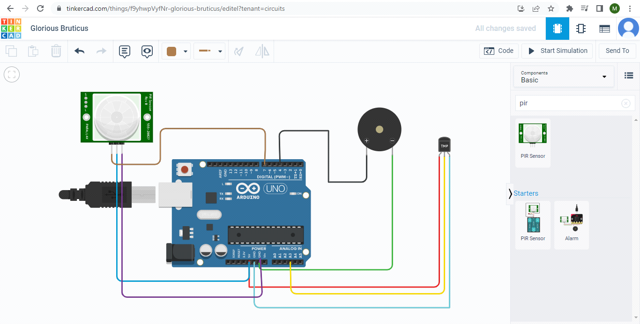

**Code:**

void setup()

{

Serial.begin(9600);

pinMode(4,OUTPUT);

pinMode(7,INPUT);

}

void loop()

{

int mov=digitalRead(7);

double dt=analogRead(A3);

double n=dt/1024;

double volt=n*5;

double offset=volt-0.5;

double temp=offset*100;

Serial.print("Temperature Detected: ");

Serial.println(temp);

if(mov==0){

Serial.println("No Motion Detected");

}

if(mov==1){

Serial.println("Motion Detected");

tone(4,100,1000);

}

if(temp>60){

tone(4,400,1000);

}

}

**Output:**

